**Tri-Chandra Multiple Campus**

**Tribhuvan University**



**Term Paper**

**On**

**Basic Statistics in Sociological Research**

**(SO 582)**

**Submitted To:**

**Narayan Satyal**

**[ Department of Sociology ]**

**Submitted By:**

**Bikash Saud [Roll No.: 25]**

**Question**

1. In which condition standard deviation is used in statistical research? The score in the third semester exam of students in two classes A and B have the following means and standard deviations.

Class A: mean: 78 and standard deviation: 5

Class B: mean: 78 and standard deviation: 15

What can be concluded about the performance of students in these two classes?

**Answer:**

# **1. In which condition standard deviation is used in research**

## **1.1 Standard Deviation**

In statistics, Standard deviation is the way to calculate the or the measure of variation or dispersion of set of values.After calculate the value of standard deviation determine the what it means,

* If the value of standard deviation is low then it indicates that the value tend to close to the mean of the values set.
* If the value of standard deviation is high then this value indicates that set of values are spread out over a wider range, not towards the mean value.

Standard deviation is abbreviated by SD, and it is commonly represented by greek word sigma (σ) in numerical calculation or text.

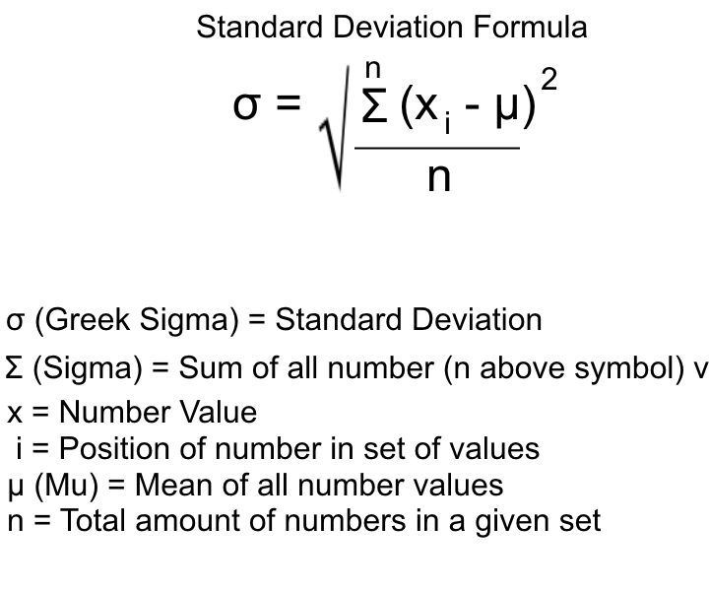

Standard Deviation is a useful statistical measurement to determine where certain numerical values lie in a large group of numbers. It is used to make some calculations of behavioral and social science. The standard deviation is especially helpful during tests where students' test scores are ranked among their peers to see how well their placements are. Some tests even give grades based on the standard deviation percentile rather than the test score.

## **1.2 When use Standard Deviation**

Standard deviation is used in various social sciences and behavioral problems. Researchers analyze their data by looking at the variability and breaking that variability down into its parts. To describe any set of data we use following characteristics:

* The form of distribution of data
* Mean value of the dataset values
* Dispersion of data

These characteristics are very useful in the standard deviation and these three are not dependent on each other. I.e. knowing the mean value of the dataset is not related to dispersion of the dataset, similarly, if we know the distribution of data then it is independent of dispersion or mean values. Variability used in different sectors to find the divergence of the data from its mean values and it is commonly used in the statistical and financial sectors. For Example, if we make two group, one is classroom students and another is Playground, in playground child and their parents are present but in classroom there is only students are present, if we start to looking the average height of student of classroom and average height of playground parent and their children is also same with classroom is similar. But we can see the height of classroom students is almost similar(less varies) in their own group but in case of playground parents and children's height varies a lot. In the social sciences, the people or the groups that researcher’s study may be exposed to the same treatment or conditions, yet they show different responses to that treatment or condition. All the scores of people and the groups are different. Here, researchers try to explain how individual or group scores are different. If there are the same score values then the value of standard deviation is zero.

Standard deviation is used to find how the individual response differs from the mean value. For example: if we research a particular topic and get the result from an individual, this result provides an indication of how far the individual responses to a question vary or “deviate” from the mean. SD tells the researcher how spread out the responses are — are they concentrated around the mean, or scattered far & wide? You can also use standard deviation to compare two sets of data. For example, a weather reporter is analyzing the high temperature forecasted for two different cities. A low standard deviation would show a reliable weather forecast.

There are various conditions where we can use the standard deviation. Some of the following conditions were Standard deviation used.

If any company or organization wants to know about how our employee salaries differ from mean value then in this condition they need to find out the standard deviation. So that we can say that standard deviation is used in different organization government offices. For this they need:

* all employees salary
* How many total they invest on average into the employee.

Similarly, if social researcher interested in calculate the to knowing the value of population standard deviation, then researchers normally calculate the population standard deviation in the following condition:

* The researcher has the entire population, or
* The researcher has a larger population sample, but he/she is only interested in this sample and does not wish to generalize finding to the population.

In statistics, researchers are usually presented with a sample from which the researcher wishes to generalize findings to a population, and the standard deviation is no exception to this. Therefore, if a researcher has a sample but wishes to make a statement about the standard deviation from which the sample is drawn, the researcher needs to use the sample standard deviation. Similarly standard deviation is also used in school student age deviation, student obtained marks calculation, similarly we also use the standard deviation to find the poverty level of all population from the country mean value.

In the question, here two groups of students are provided Group A and Group B, where the value of mean is same which is 78 and the value of standard deviation is different which is 5 and 15 respectively. Here the value of standard deviation of Group B student is more than the value of standard deviation of student Group A, thus we can say that the students of Group B have more Dispersion in their test than student Group of A. So we can conclude that the student of Group B has less performance than student of group A.